# 34: about spring boot

N-tier

**Challenges with Monolithic Application:**  
1. Increased Time to Market  
2. Less maintainable  
3. wastage of Resources  
4. High Recovery Time  
5. Large and Dependent Teams

Web application  
Web designers(UI)  
Web developers(Back End Developers)

**Benefits of microservices architecture**

1. Time to market is reduced application is divided into microservices that are independently built, tested and deployed.

2. Maintainable

3. Scaling and utilization of resources  
 Horizontal scaling:  
 No. of instance of service  
 Vertical scaling:  
 CPU, RAM(

4. Less Recovery Time  
5. Small and independent Teams

**Standards for Microservices:**

1. How to Decompose online shopping Cart

* Product CatLog management
* Inventory Management
* Order Management
* Delivery Management
* User Management
* Product Recommendation
* product Reviews         ....

2. Building and Deploying

3. Design the individual services carefully

        service 1        service 2

            DB

        DB    Service 1    service 2

**Microservices implementation using spring boot:**

Spring Boot==== Spring Framework    + Embedded server  - XML configuration or Less Annotations

Account:

1. Retrieve the list of all customer accounts along with details
2. Retrieve a particular account's details by sending account id as an identifier in the request
3. Register or add an account
4. Update a perticiular account's details that are identified by account id     (CRUD)
5. close or delete an account

Flow in spring boot:

request---->controller----->service---->dao---->db

@**SpringBootApplication** -> @Configuration+@ComponenetScan+@EnableAutoConfiguration

@**RestConroller**--->@Controller+@ResponseBody

http://<ip-address>:<port-number>/<context-path>/end-point

http://localhost:8080/Account/api/

Spring hierarchy how starter is managed automatically:

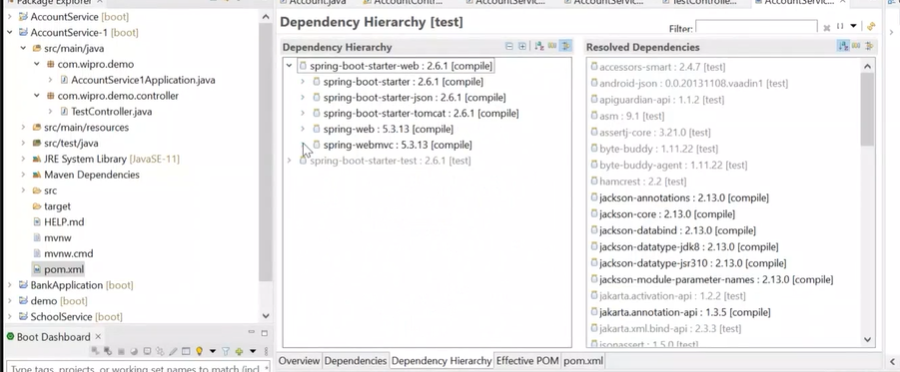

Eg: CRUD operation with Account (with static data (not connected with any db))

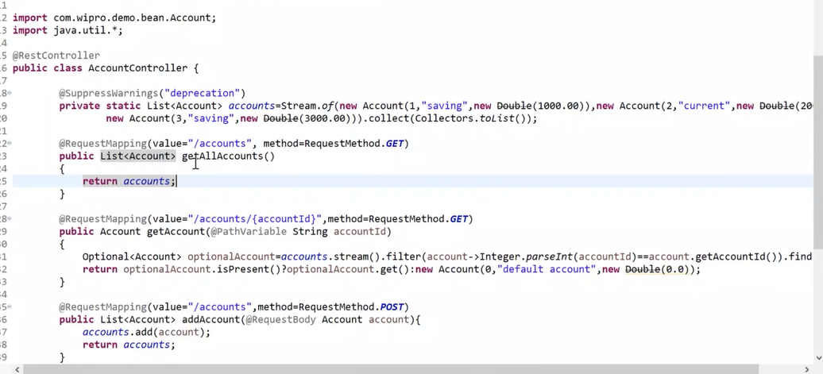

# Netflix and spring cloud And one basic microservice example

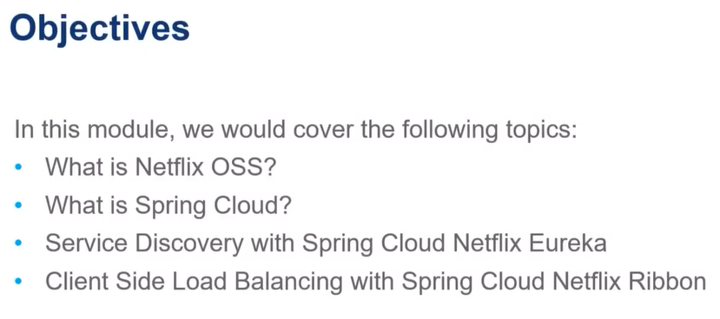

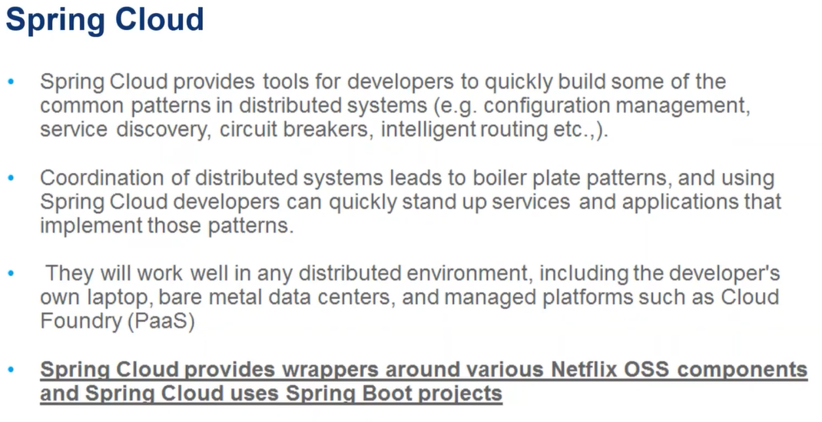

## **common Patterns in distributed environment:**

1. Load balancing  
2. Falut Tolerance(Circuit breaker)  
3. Routing  
4. Service Registry & service discovery  
5. Exceternalizing Configuration(Centralized configuration)  
6. Logging

require high scalability, performance and high availability

**Advantages:**  
developers focus on business logic  
Easy to use  
Quick Development

**Distributed Cloud configuration**

Spring Cloud Configuration,

cloud zookeeper,

spring consul config

**Service Discovery**

* Spring Cloud Eureka  
  spring Cloud consul  
  spring cloud zookeeper

**Spring Service Communication**

spring Hystrix(fault tolerance|circuit breaker)  
Ribbon(Load balancing)  
Spring zuul

**distributing Messging**

Kafka,

RabbitMQ

Understand what is synchronous and asynchronous communication with example.

**Service Discovery in MicroService Architecture:**

Service A Service B

There are two main service discovery pattern:  
1. server side discovery pattern  
2. client side discovery pattern

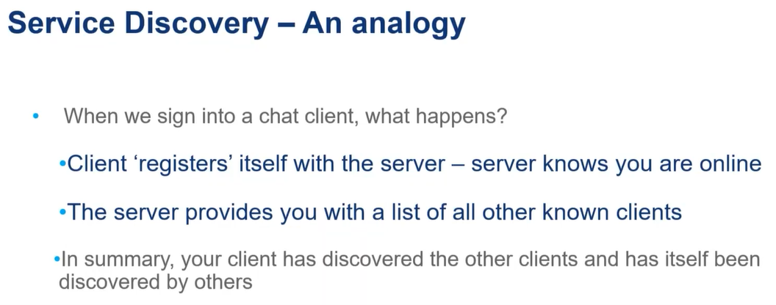

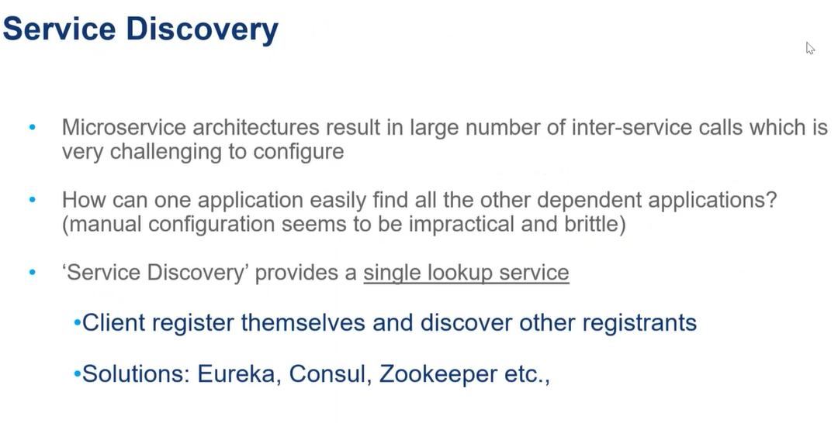

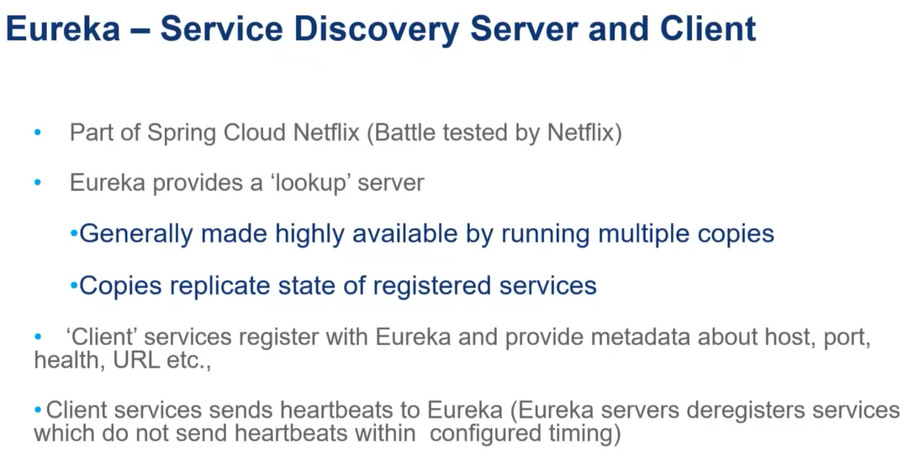

http://localhost:8080/payroll/1

Spring Cloud Eureka is a rest based service that registers the services dynamically.  
It has a server and client-side component and maintains a centralized list of registered services.

**Eureka Server Implementation**

1. create a spring boot application and add spring cloud starter netflix eureka server dependency  
2. On main class add the Annotation @EnableEurekaServer  
3. In application.properties  
 server.port=8761  
 eureka.client.register-with-eureka=false  
 eureka.client.fetch-registry=false

Ex:

Eureka server

Student Service (client)

School Service (client)

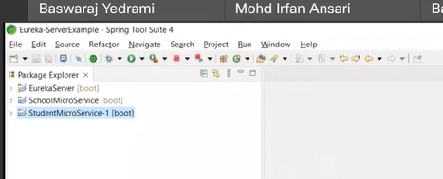

Diff between app.properties/bootstrap.properties/application.yml?

**Steps to create Eureka server:**

1. create simple spring boot project

1. add eureka-server **dependency**
2. add **enable-eureka server** annotation in main class
3. add config in property file.

**Steps to create client :**

1. create a simple spring boot project
2. add eureka-client **dependency**
3. add **enable-eureka client** annotation in main class
4. add config in property file.
5. Add rest template

Rest template is used in main class to the application which is going to consume other service:

(in this example schoolMicroservice is going to consume studentMicroservice)

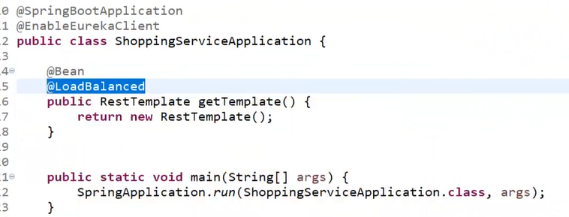

# Monday:

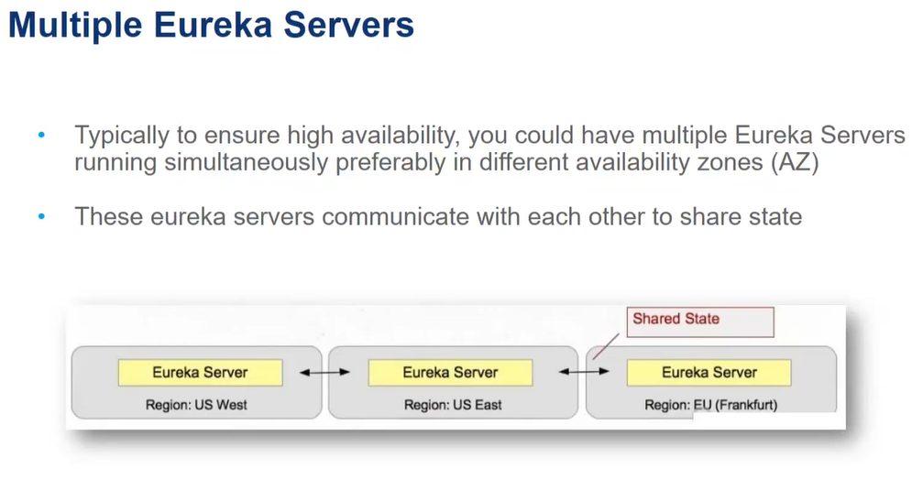

## How to configure multiple eureka servers: OR clustered servers

(This is required when we move our application into cloud)

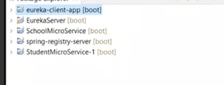

Make sure you have **admin access** for below folder path

C:\Windows\System32\drivers\etc

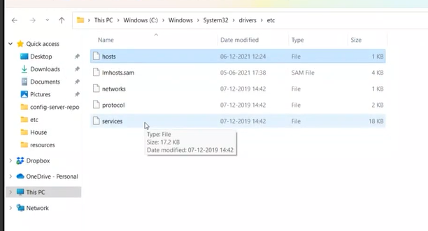

Property file: from **spring-registry-server** application

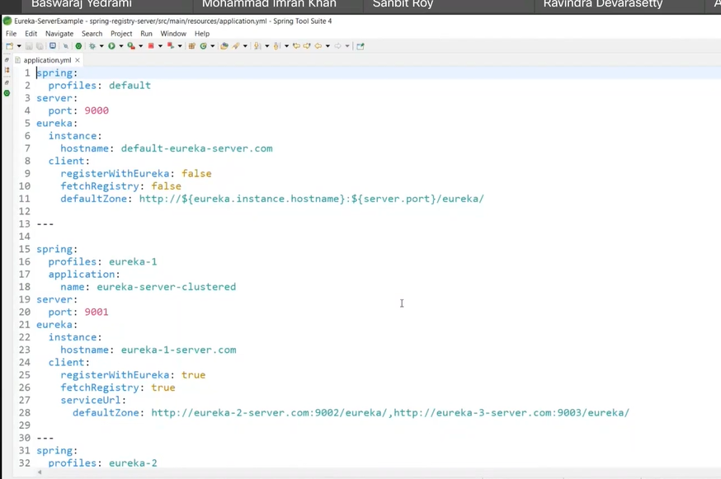

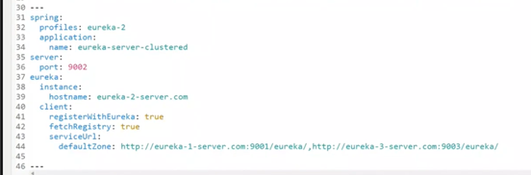

In case of multiple eureka server configuration make sure **profile-name and port number** will be unique

**Profiles** is nothing but mentioning different environments like staging/production/default

When we are working with **single eureka-server** defining profile as **default** is fine

Import: above is a single application we created and we are going to run 3 different instances.

Propert file: from **eureka-client** application

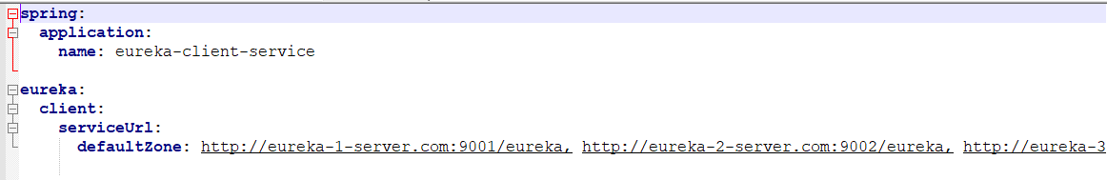

Purpose of using this application is, Because our client service has to aware of all eureka-server.

For example if server 9001 is down, it has to get info from server 9002 like wise

Before run, Make sure you have entry of below eureka server in hosts file:

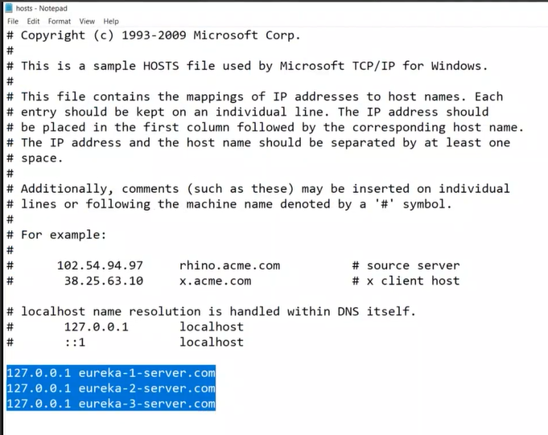

### Step 1:

Open cmd, go to eureka server project path : target folder and run with command as

Java -jar <jarname> --<profile name>

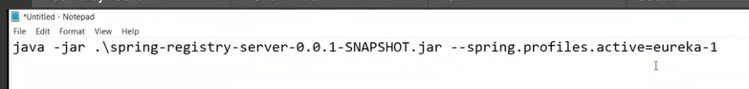

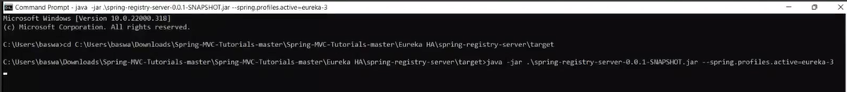

//similarly run all eureka server instance seperately

### Step 2: How to access eureka server :

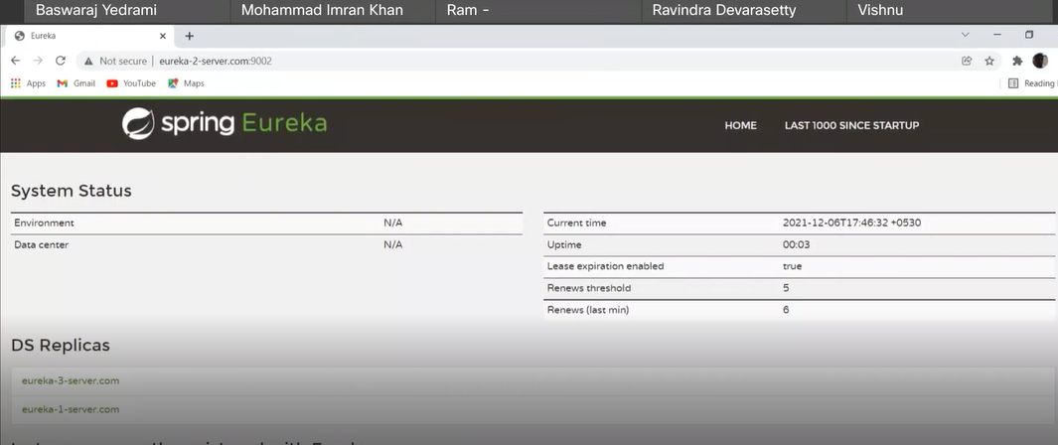

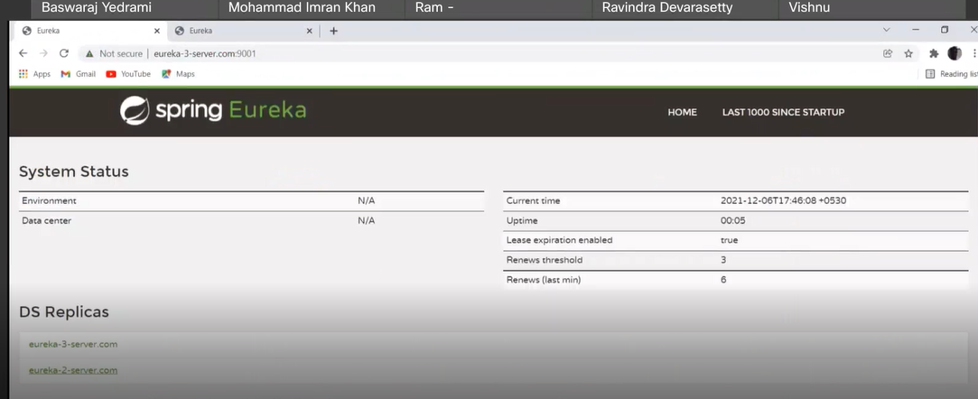

## **Ribbon as load balancer:**

Provides client-side load balancing

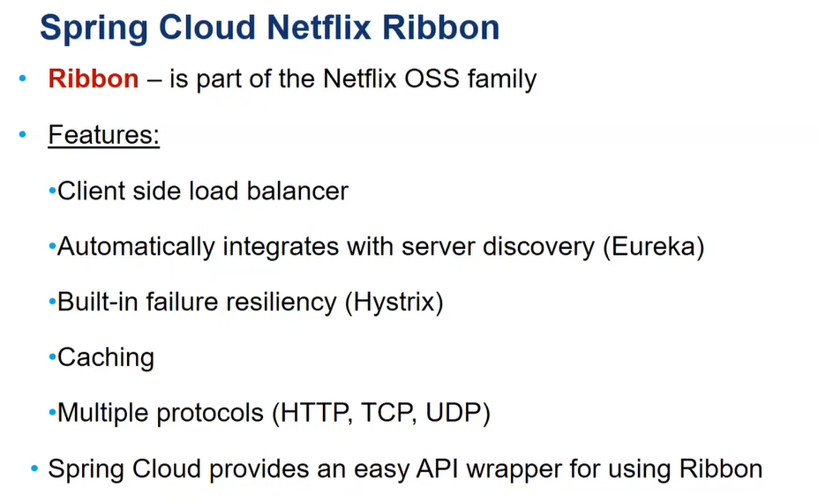

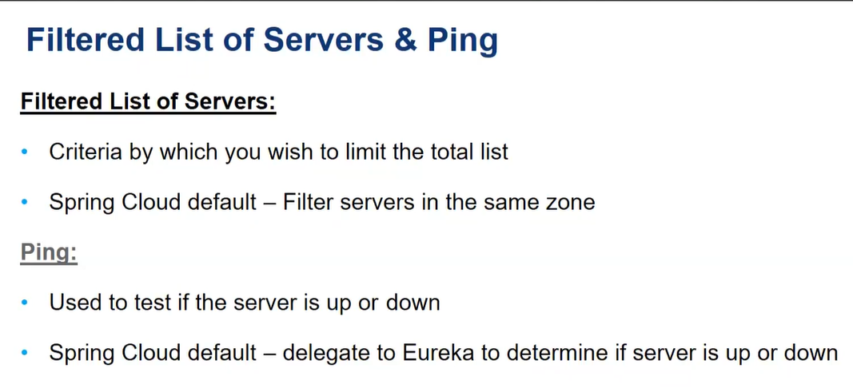

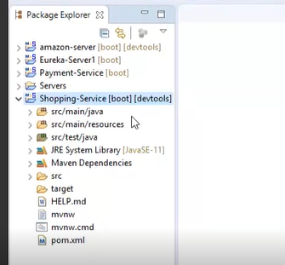

**Client services: payment and shopping (It’s a consumer service i.e consuming payment service)**

**Eureka-server: url for above application**

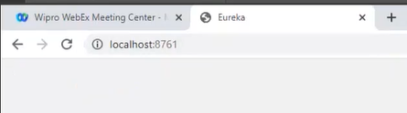

### **How to run multiple instances:**

Right click on project :run as : run configuration : environment : edit : change port number (say 8405) : run

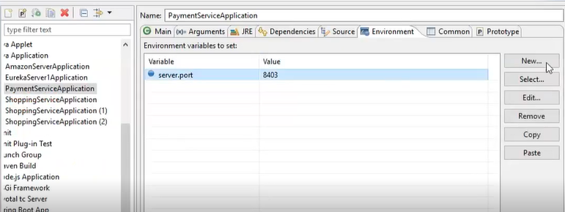

Run eureka-server now and you can find multiple client service instance below now (8403 and 8405):

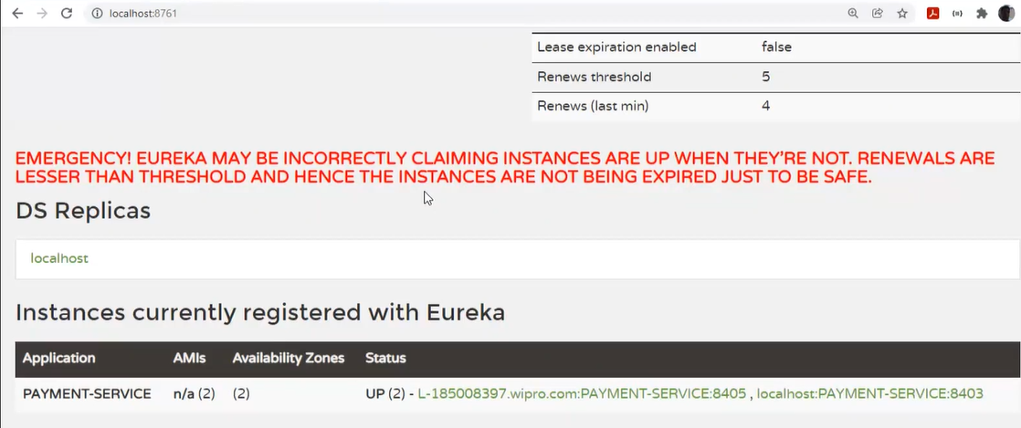

### **Demonstration of Ribbon load balance will work :**

Demonstration of how ribbon load balancer using different payment instances (we can identify by port displaying in result)

Steps:

1. Make sure, above multiple payment instances are up and running
2. Run shopping application.

In below example, as you see, created 3 payment instance and 1 shopping instance :

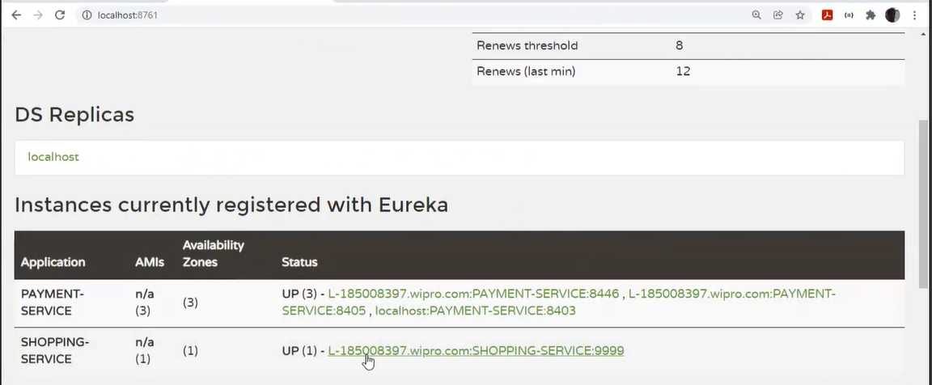

As you see below, ribbon is using payment instance which is running on 8403 and in another below screen shot using payment instance with 8405

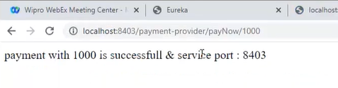

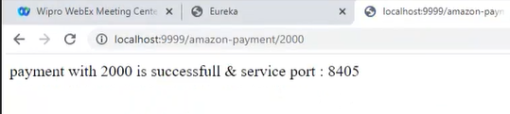

**Important Note:**

1. This is a client side horizontal scaling.
2. When ever we were working with monolithic architecture, we were using predominantly server side load balancing. But in case of microservice we have client-side LB
3. Here we are doing scaling manually since it’s a local. but when we moved to cloud we have option to do auto scaling. (Using 12 factor/ by externalizing the property)
4. But currently in real project we are not using ribbon (its deprecated now), but we will go with **spring cloud load balancer** implementation. (more prefered)

OR we can go for **resilience4j** load balancer.

FYR:

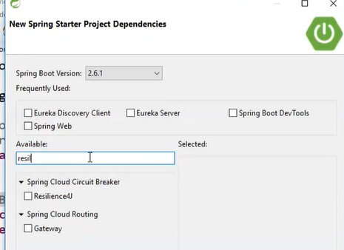

1. **Flow**: API gate way – eureka server – individual microservice

### How to implement ribbon load balancing?

# Circuit braker : hystrix

From spring 2.5 onwards it’s not available.

## Cascading failuare**:**

If any failuare happen in one node and some other node is dependent on this node, So automatically it affect to all dependent node as shown below.

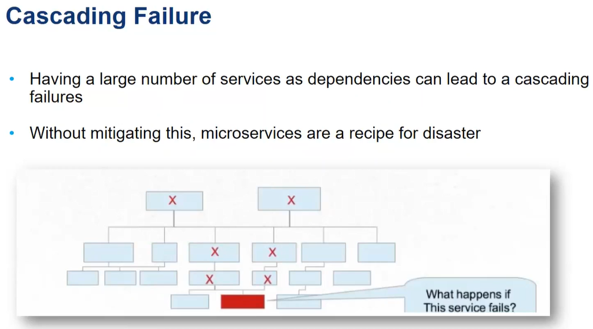

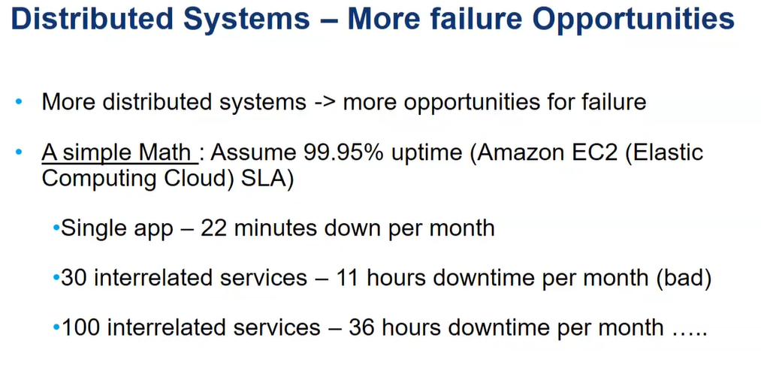

## Circuit breaker pattern:

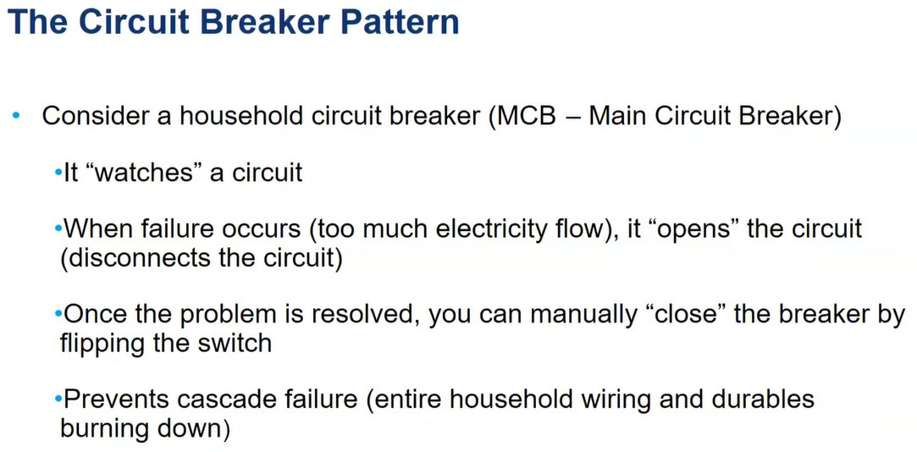

Solution :

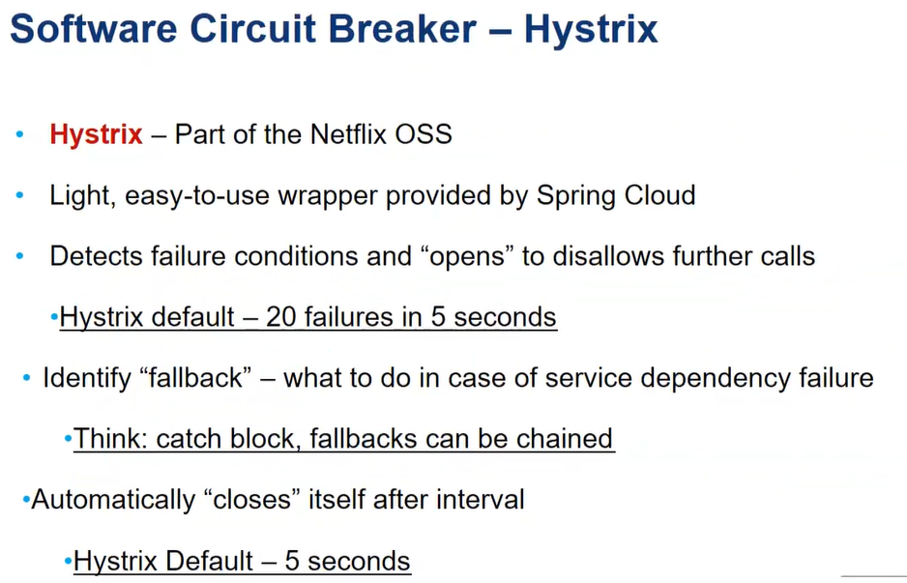

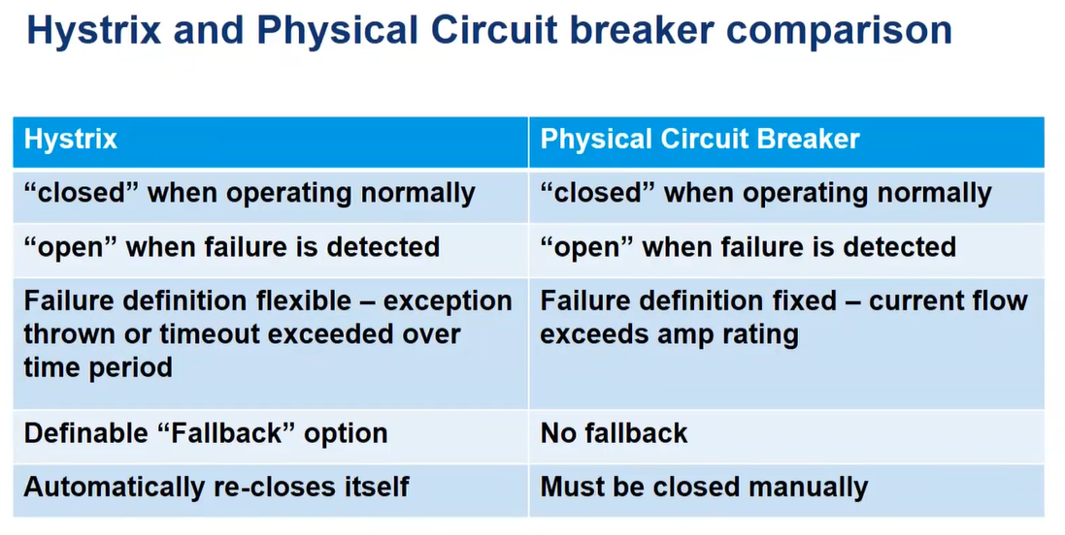

## How the Maximum downtime will calculated for 99.99%

24 hours per day and 365 days per year= 8760 hours per year.

8760 * 60 = 525600 minutes per year

99.999% uptime means accepted failure change=0.001%

525600 * 0.001% = 5.256 minutes for one service

(Think suppose if we have 100 services then 5 min * 100)

## Different states of Circuit Breaker

**Closed**:

Everything is norma( all calls pass through to the services)

When the number of failures exceeds threshold the breaker trips, and goes into Open state.

**Open**:

Circuit breaker returns an error for calls without executing the functionality.

**Half-Open:**

After a timeout period, the circut switches to a half-open state to test if the

underlying problem still eists.

If a single call fails in this half-open state,

the breaker is once again tripped(open state)

If it succeeds, the circuit breaker resets back to the normal state(closed)

Hystrix is built on top of the command pattern.

Annotation @HystrixCommand(when applied to the method having a third party or downstream system call,

wraps that method and looks for the faults in those external calls and sends the control to the

secondary method.

## Implementation for Hystrix

1. add the dependency in pom.xml

spring-cloud-starter-netflix-hystrix

2. Add @EnableCircuitBreaker annotation to the main class

3. Update the your class and specify, primary, secondary and fail-fast method

* Primary means : which is expected method to execute
* Secondary means: In case of particular method failure, which method has to execute.
* Fail-fast means:

Example in video, Not used the eureka-server. Demonstrated only with student and school service. (But using with eureka-server is recommended)

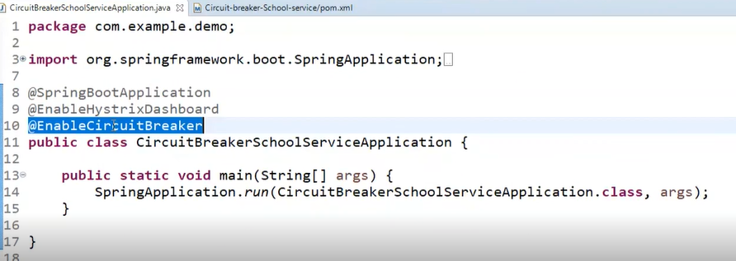

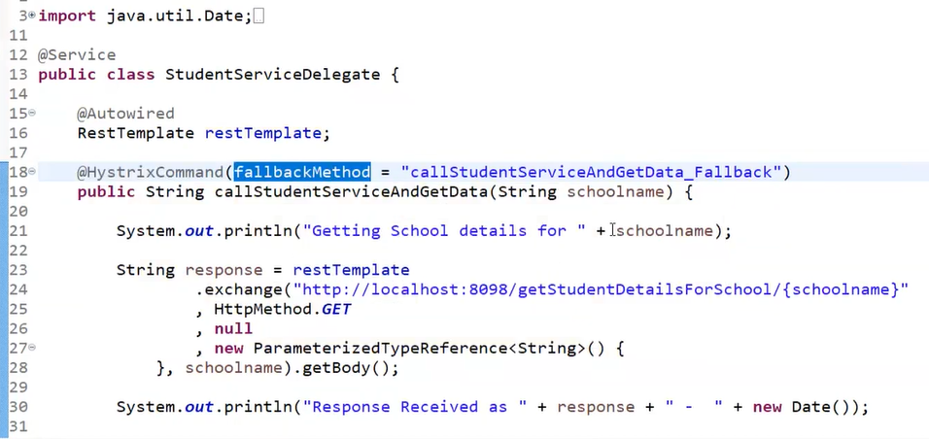

In above example, we are not using eureka-server, that is why we are hard coded url directly. (line 24)

If above method is failed to call, then it redirects to below method: (line 18)

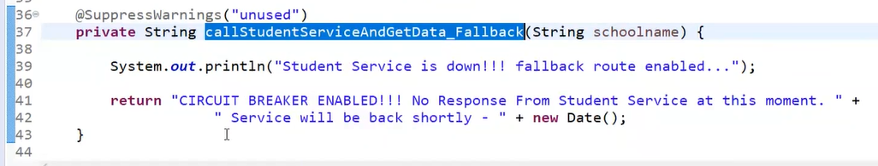

How to test:

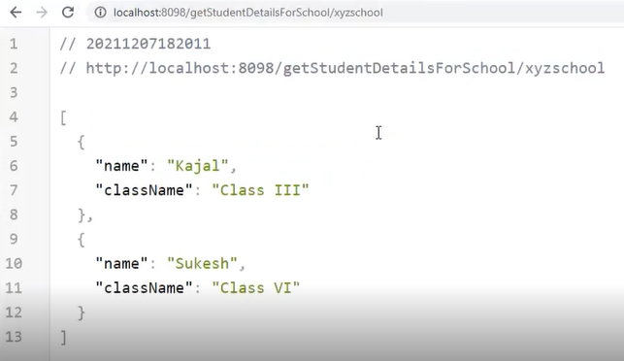

Now we’ll make student service down manually so that its going to call fallback method:

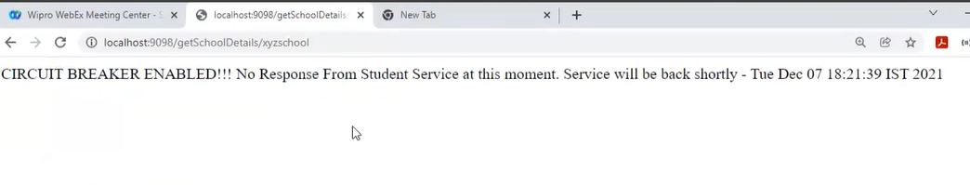

## **\*\*\* What are the conditions we can go for circuit breaker?**

1. Suppose my server has capacity to handle 100 request at a movement. But my queue is having 1000 request, that time my server may not respond So that time we can mention how many request should be there in queue. i. e maximum queue size we can mention.
2. Default time-out in milisec we can mention.

### How and where we can mention above conditions?

Explore and try to implement below scenario

We have below properties to mention and we can mention where we call our fallback method (line 18)

* RequestVolumeThreshold
* sleepWIndowInMilisecond
* TimeOutInMilisecond
* Coresize
* maximumQueueSize



## Hystrix-hashboard:

### Implementation steps:

1. Add dependency
2. Enable histrix-dashboard in main class

### How to access?

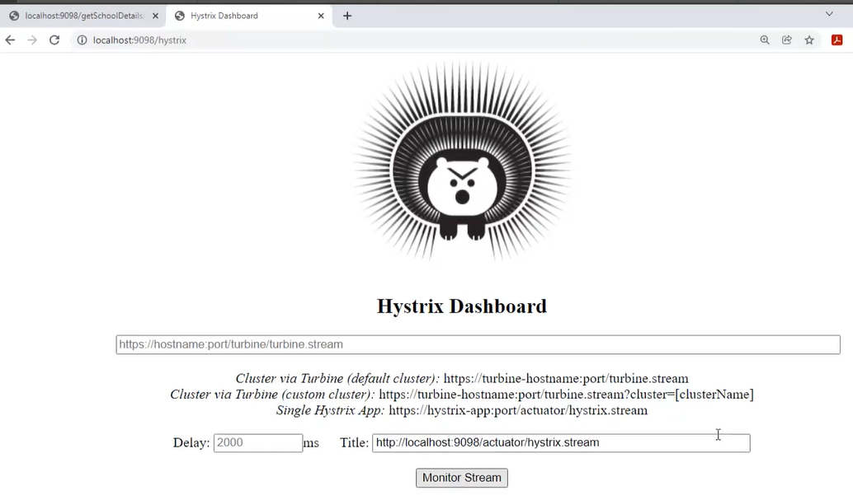

On clicking of monitor stream:

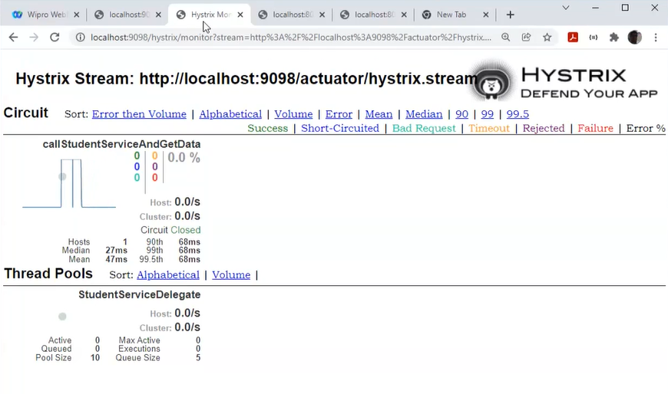

Above The colour code indicate the status of service. If request is getting fire then graph will appear, If no request the graph will be just strait line.

# ***12 factor principles:

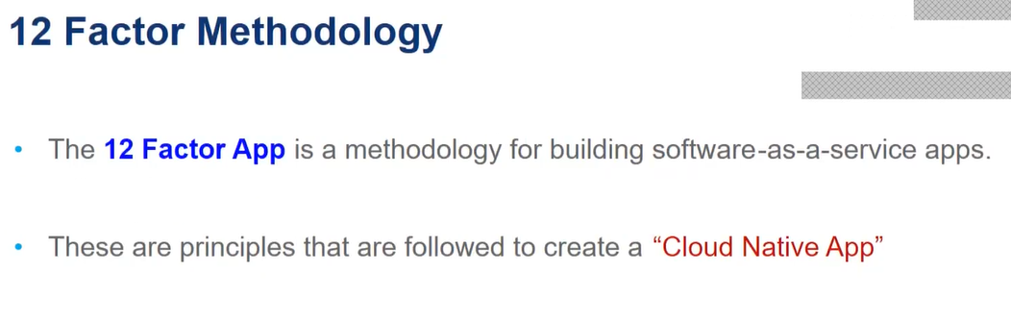

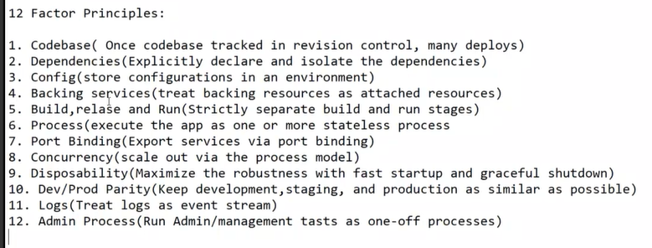

1. Even though we have multiple environments, we have to maintain single code base.

Activity of daily check-in check-out.

Storing our code into repository like svn or GIT.

1. It means, normally we download dependency and include those dependency in our class path. So, we have to avoid this. Instead of that one we can explicitly mention within the maven.

Note: In maven Usually When we do Install command it downloads to local repository

1. Usually we have 2 kind of configurations:

**Application** specific config: ip addr, host name, port number

**Environment/service** specific configuration: suppose when we pushing into our application into cloud, at the time we are using database of cloud, so those connection related details will go to service specific configuration.

We should not do hard code of configuration values instead we have to use environment variables as best practice.

This is v much important because lets say for example if we want to change current database with another database, configuration wise we need to do lot of changes. So in order to avoid this config with environment variables is good.

***What is **externalizing the configuration**?

1. Backing service is nothing consuming one service with another service. Example when we working with lets say banking, once any transaction done we need to send alert through message, need to send email notifications. So these external (message service, email) services consumed by our application. So we treat these are attached resources.
2. Build is nothing but transforming our source code into executable jar/war.

Release : Then that jar/war combined with some configuration in deployment environment and make our application to run.

Run: running our application.

So for all above these process industry is using, docker image, CI/CD pipeline with Jenkins.

1. Our application should work as stateless. Our application state should save in database instead of in-memory.
2. ***
3. Scaling our application.

What you mean by horizontal scaling: creating multiple instance of our application

What you mean by vertical scaling: adding additional hardware to our application like RAM, processors etc.

What you mean by Containerization: its like packaging our code base/ dependency/run time environment altogether as a one image.

1. Maximise the robustness with fast start-up and graceful shutdown.
2. Keep dev/staging/prod as similar as possible. The main reason is, it reduces the showing of bugs in specific environment.

Eg: If your using h2 dtabase in dev, same use in staging and prod like that.

1. Logs are used for trouble shooting purpose. For error tracking. Splunk in case of microservice.
2. ***

In above at least first 5 are v common we need to implement. And these are the best practices (12 factor principle) and good to follow.

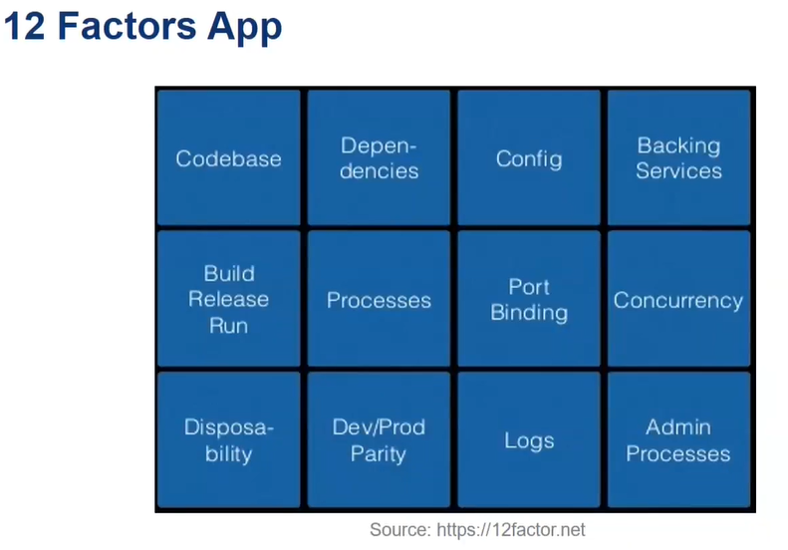

**Difference between authentication and authorization?**

In simple words who are you (authentication) and what you can do (authorization)

# API gateway: zuul

## Definition

It’s a single point of entry for all requests. And mainly used for routing.

Gateway is the layer and that sits between client and server which relies on.

Requests Before and after hitting our application what I want to process is nothing but API gateway.

**challenges With Individual Services**

- different Ports

- different Addresses

- different API & Paths

gateway service defined as the single point of entry for all clients.

**A gateway Service provides:**

1. Dynamic Routing & delivery
2. Security & filtering
3. Auditing & Logging
4. Request Enhancement
5. Load Balancing
6. Different APIs for different Client

2) Suppose if we have 100 service and if we make 100 authentication to each service its not good, So using gateway we can make centralized authentication. And it will filter in case if any bad request comes.

Q) What is the difference between API Gateway provided security and Oath/JWT based security?

API Gateway-design concept. Oath/JWT-type of auth mechanism(token based)

Q) what is the use of spring cloud load balancer/resilience4j, If API gate way is already having

the job of load balancing?

spring cloud load balancer/resilience4j : is for our instances which we have created in microservices.

**Using Netflix Zuul with spring Cloud**

**Gateway flow:**

1. client send request to the Gateway

2. Gateway processes and sends request to the service

3. Service responds to Gateway

4. Gateway process response and sends it to the client

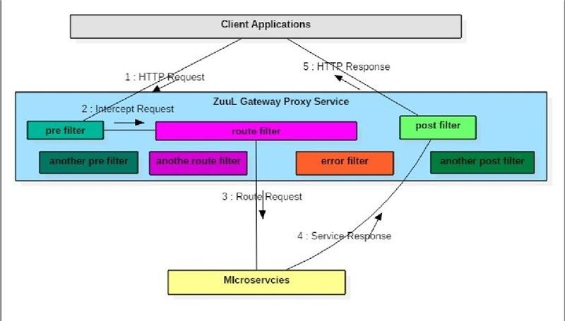

**Key Benefits of an API gateway:**

    Authenticatin and Authorization

 Processing and Validating input

 Transforming responses

Model:

 beans(Business Data)

 services(Business Logic

DAO(Persistancy)

**Zuul components:**

four types of filters that enables us to intercept the traffic in different timeline of the          request processing for any particular tarnation.

1. Pre filters(Before the request)
2. Post filters(After the request)
3. route filters(Direct the request)
4. error filters(Handle reuqest errors)

class MyFilter extends ZuulFilter {​​​​​​

    public Object run()     {​​​​​​

 //filter Logic goes here

    }​​​​​​

 public boolean shouldFilter(){​​​​​

​         //whether or not the run() method should execute

    }​​​​

​​  public String filterType(){​​​​​​

        //the type of filter:pre,route,post,error

 }

 public int filterOder()     {​

​​​​​         //The order of execution with respect to other filters of the same type

 }​​​​​​

}​​​​​​

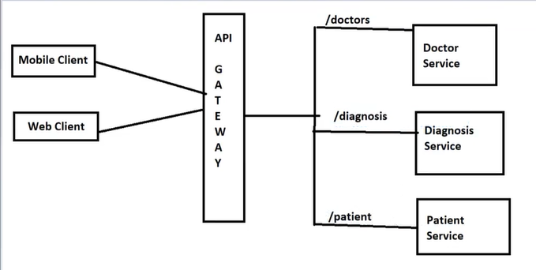

## Example:

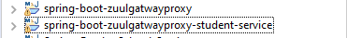

How to test:

If you see below screen shot, we have 2 end points (getStudentDetails and echoStudentName) in student service which is running on **8090** port.

And here we are running gateway service on port **8080** and which redirects to student service based on below route specification from property file.

zuul.routes.student.url=http://localhost:8090

(api gateway redirects to student service, whenever it finds /student in given url )

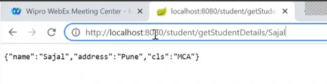

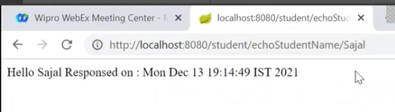

# Externalizing configuration: Spring cloud config server

## why we need externalizing the configuration? And How you can achieve it in microservice?

To overcome below problems we need externalizing the configuration.

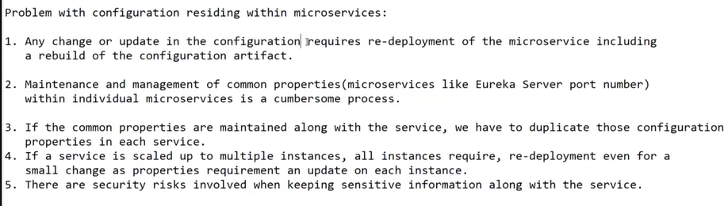

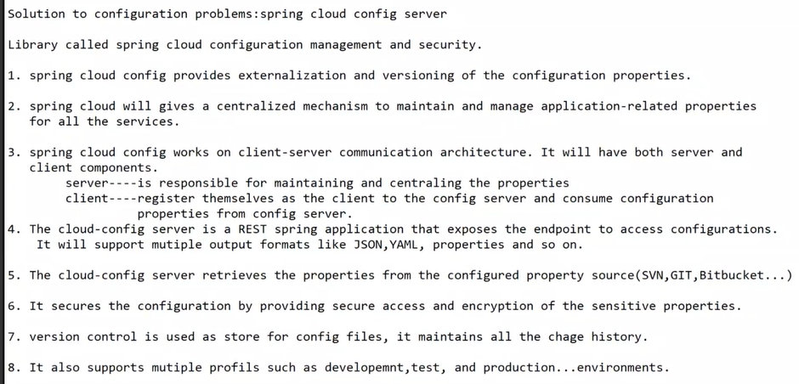

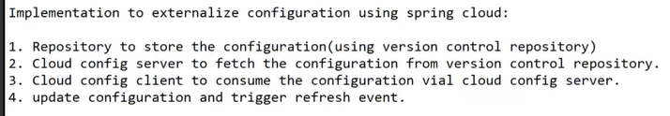

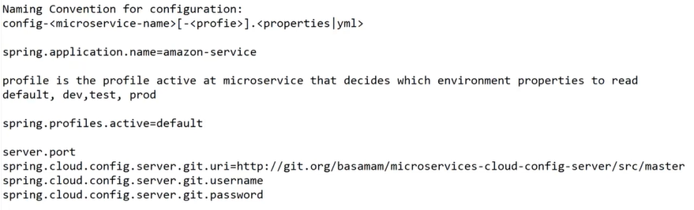

**//server side**

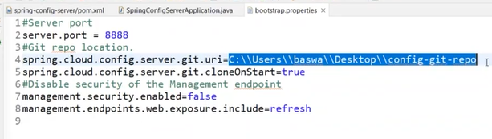

**//client side**

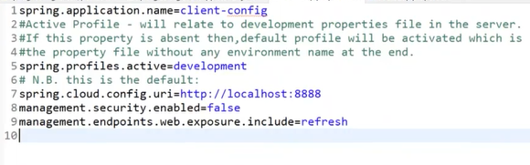

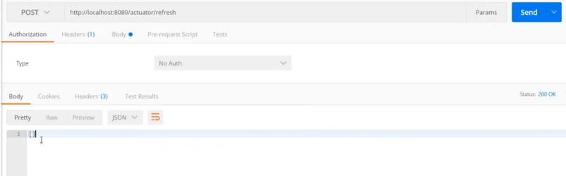

[ ] means no modification in property file,

# Fault tolerance: Zipkin

## theory

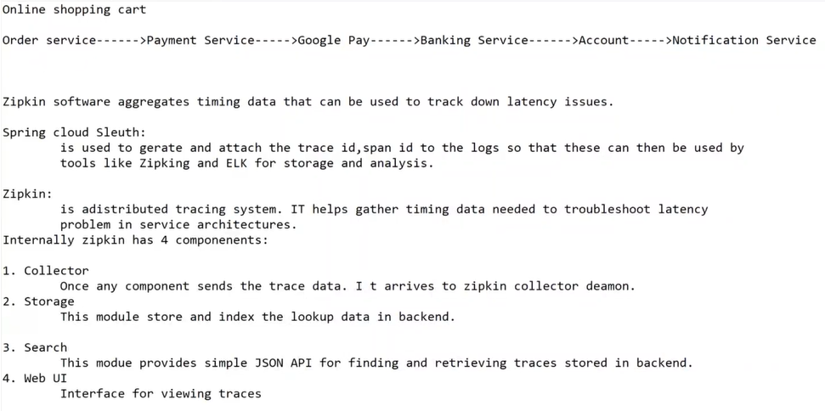

## How to instal:

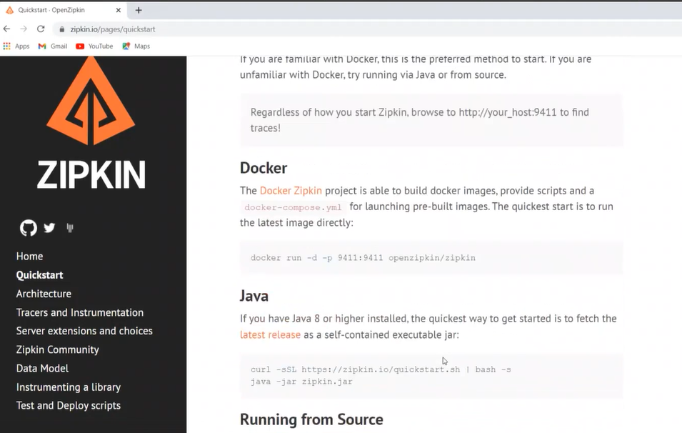

Click on **latest release link** under Java

How to run after download jar:

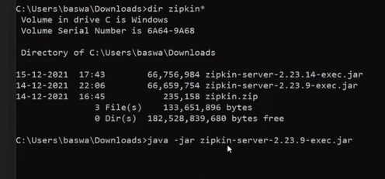

So, now its started on port 9411 (ref below screen shot)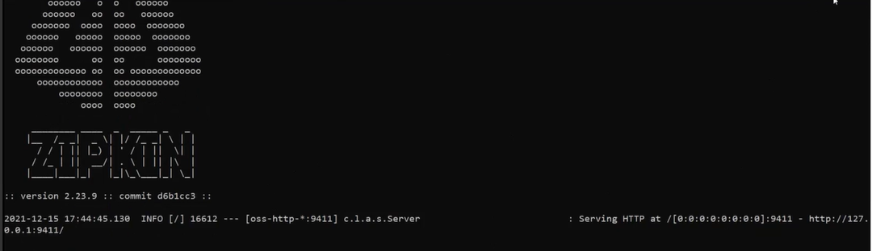

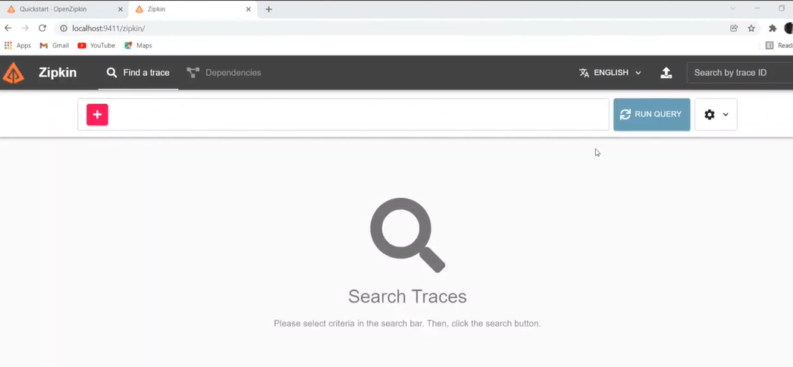

## Example

Here in this below example, 4 microseervice is created. Ms1 is calling ms2 then ms2 will call ms3 and ms3 will call ms4 to get response.



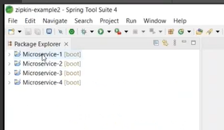

Add 2 dependency to all 4 microservices:

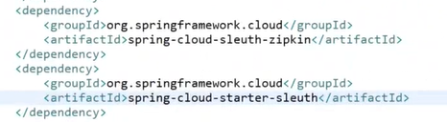

Sleth is used to generate id and zipkin is used to provide web UI (through this we can see where it went wrong)

In propert file:

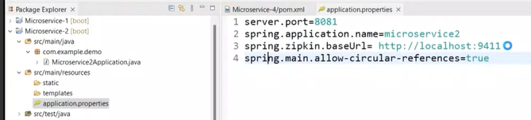

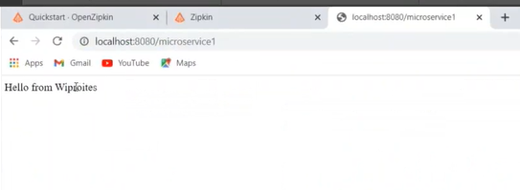

Note down in screen shot below, service name, trace id and span id from all 4 microservice logs:

You can see for each request same trace id with all 4 services but span id will change service to service.

Note:

these trace id and span id is generated by sluth.

If you hit the same request again and you can find different trace id and spare id again.

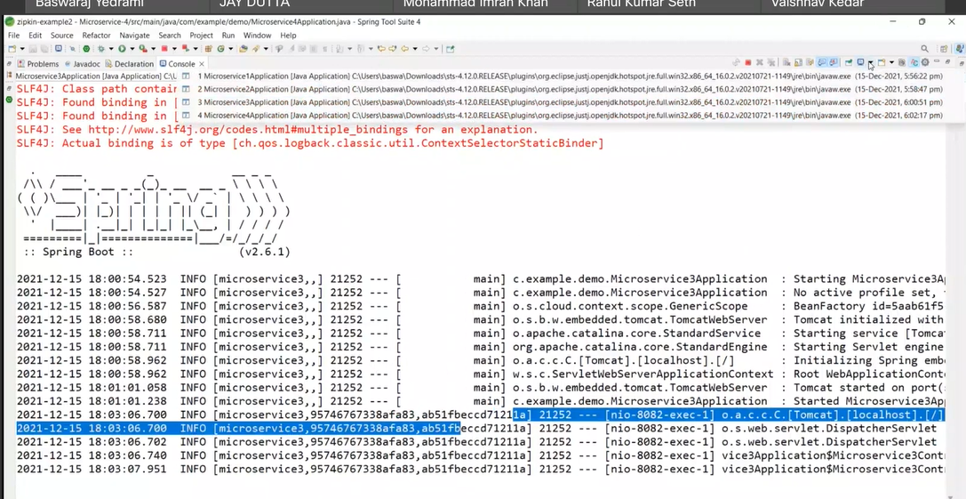

In below, you can see request history in zipkin UI with trace id:

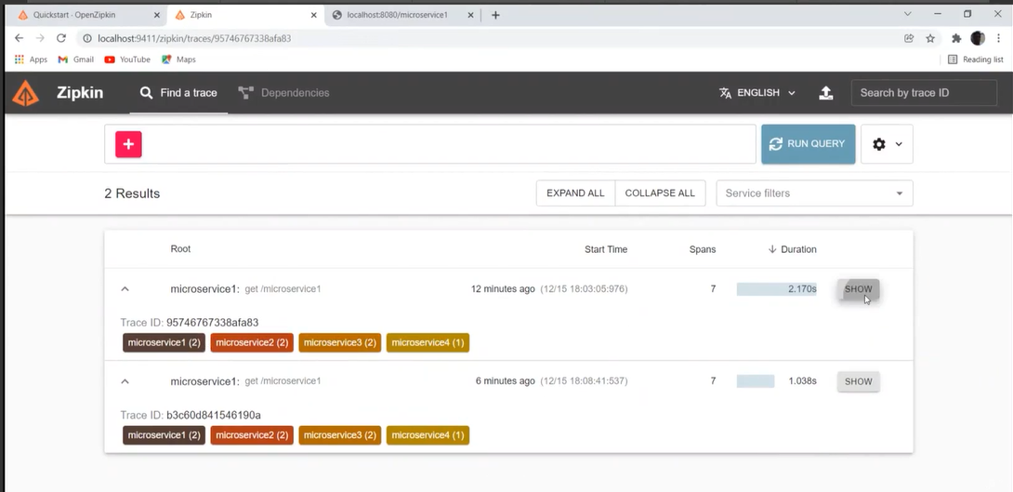

**Note**: Now make any one service down and check zipkin UI. In below case we made microservice 3 to down.

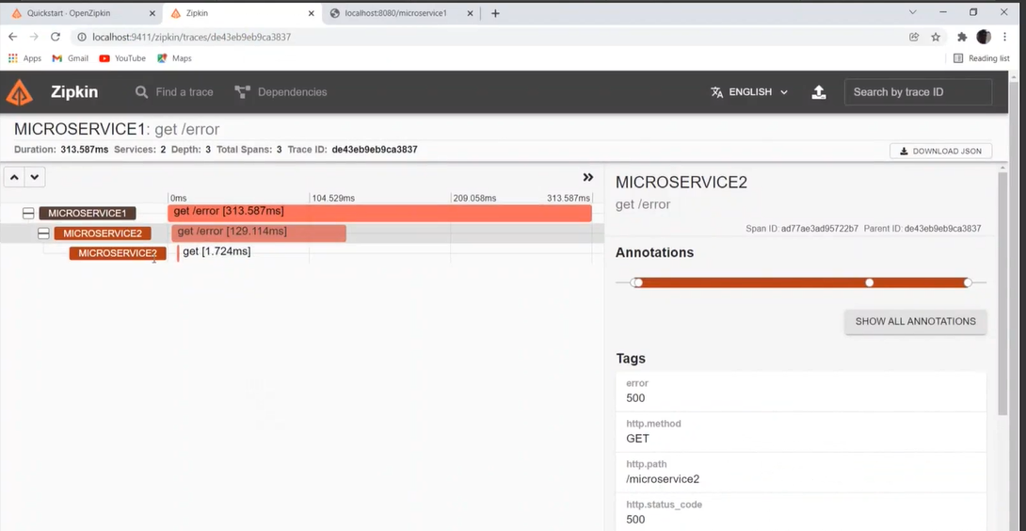

# Reactive programming:

## Introduction to Reactive Programming

client----->request------>Web Server----->static request

------>dynamic request----->servlet container  
------->web.xml file to identity(url-pattern) the servlet  
-------->Servlet will be loaded into the memory  
-------->Create a instance---->life cycle methods will called

Servlet container---->dedicated thread pool--->will handle the http request

per request---->one thread will be created

application will only be able to handle a number of concurrent requests that equals to the size of the thread pool.

FYI: suppose If a thread pool size is 100 at a time we can proceed 100 requests. Suppose if we get 110 request then other 10 request will go to waiting state.

So we are looking here for to over come this.

Thread per request model could become quite costly for the applications with a high number of concurrent requests.

Using traditional imperative programming with synchronous request/response model for inter-service communication means that thread frequently get blocked waiting for a response from the another service results-huge wastage of resources.

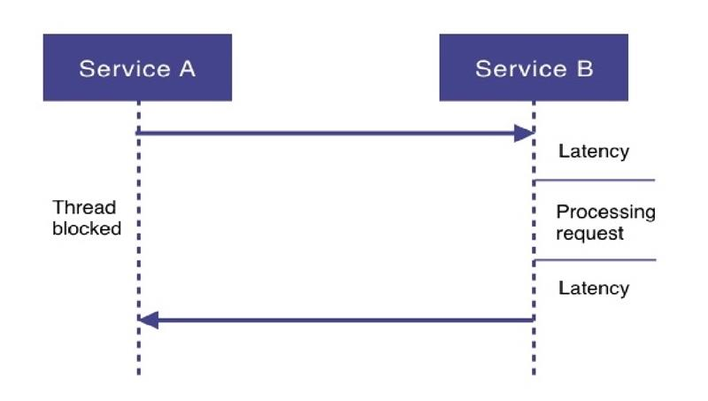

Latency means **we don’t know how much time it take** to proceed.

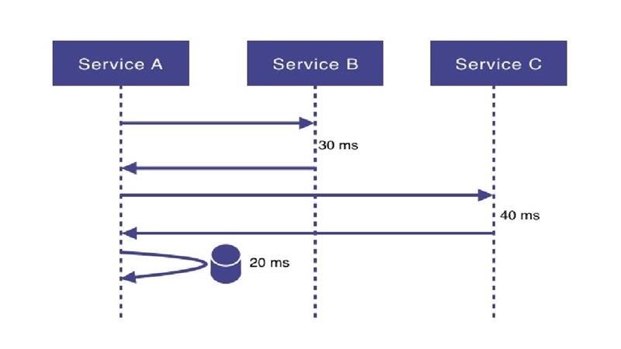

If service A interacting only service B then we may take response time of 30 ms.

Suppose if service A need to interact service B then Service C then it may take 40 ms.

**Advantages of Reactive Programming:**

1. move away from the thread per request model and can handle more requests with a low number of threads.

2. Prevent threads from blocking while waiting for I/O operations to complete

3. make it easy to do parallel calls

4. support "back pressure", giving the client a possibility to inform the server on how much load it  
can handle.

Def:  
reactive programming is about non-blocking applications that are asynhronous and event-driven  
and require a small number of threads to scale.

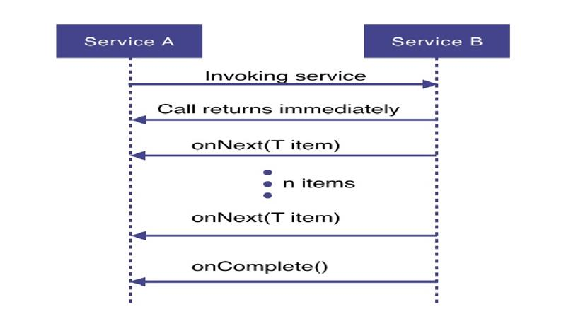

**Modern applications to be designed :**

* Responsive(responsding in a timely manner)
* Resilient(staying responsive also in failure situations)
* Elastic(staying responsive under varying workload)
* Message Driven(relying on asynchronous message passing)

specification covers some interfaces:

public inter publisher<T>  
{  
 public void subscribe(Subscriber<? super T> s);

}  
represents data producer/data source and has one method which lets the subscriber register to the publisher.

interface Subscriber<T>  
{  
 public void onSubscribe(Subscription s);  
 public void onNext(T t);  
 public void onError(Throwable t);  
 public void onComplete();  
}  
represent consumer

public interface Subscription {  
 public void request(long n);  
 public void cancel();  
}

## Example:

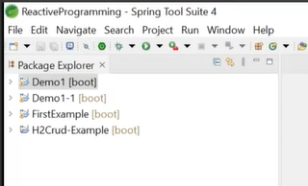

Spring provides **Webflux** with version spring 5.1

It is used to support reactive programming.

spring uses the Mono and Flux from project reactor.

Mono.just()   
Mono.empty()

Mono means 0 or 1 element return .

Flux means 0 or n element return.

Select spring Reactive web below.

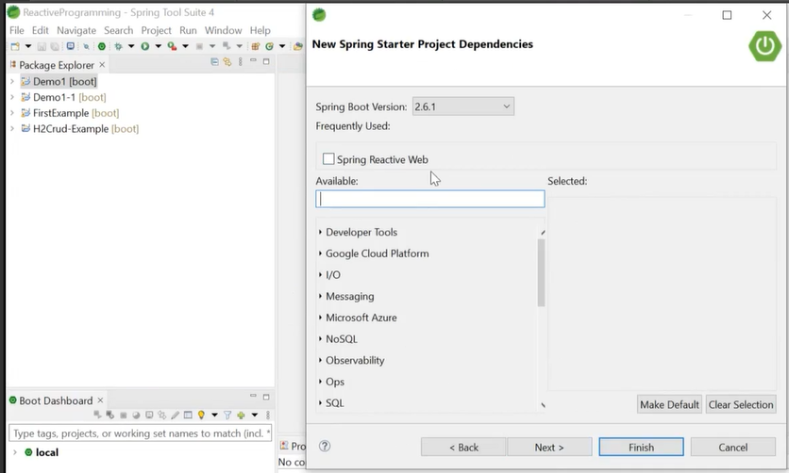

Add below dependency:

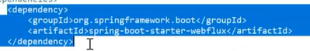

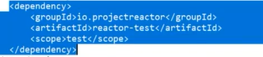

# Assignment

Below 2 assignment are mandatory: s

1. Quick assessment

Takes max of 20 mins

<https://wilearn.sumtotal.host/core/pillarRedirect?relyingParty=LM&url=https:%2F%2Fwilearn.sumtotal.host%2Flearning%2Fcore%2Factivitydetails%2FViewActivityDetails%3FUserMode%3D0%26ActivityId%3D47035%26ClassUnderStruct%3DFalse%26CallerUrl%3D%2Flearning%2Flearner%2FHome%2FGoToPortal%3Fkey%3D0%26SearchCallerURL%3Dhttps%253A%252F%252Fwilearn.sumtotal.host%252Fcore%252FsearchRedirect%253FViewType%253DList%2526SearchText%253DMicroservices%2526startRow%253D0%26SearchCallerID%3D2>

1. Top gear assignment:

# Auth:

OAuth2 is more commonly used authorization in industry right now. You can find huge examples in internet.

## def

OAuth2     is the User Delegated Authorization mechanism

 User Delegated Authorization allows a client application to ask     Resource Owner for permission or grant to access a protected     resource on behalf of the end user.

    OAuth2 is a protocol for conveying authorization decisions in the     tokens and provides a standard way of objtaining those tokens.

## Four different roles with in OAuth2

1. Resource Owner:  An entity that is able to grant access to its protected resources.
2. Resource Server:  Component that requires an access token to all access to its  resources(microservices)
3. Authorization Server :

        Generates and grants self-contained access token to clients     after successfully authenticating resource owners and obtaining     their authorization

1. Client:

 An entity that obtains access tokens from authorization servers to     access the resources on behalf of the resource owner and with     its authorization.

Pictorial representation:

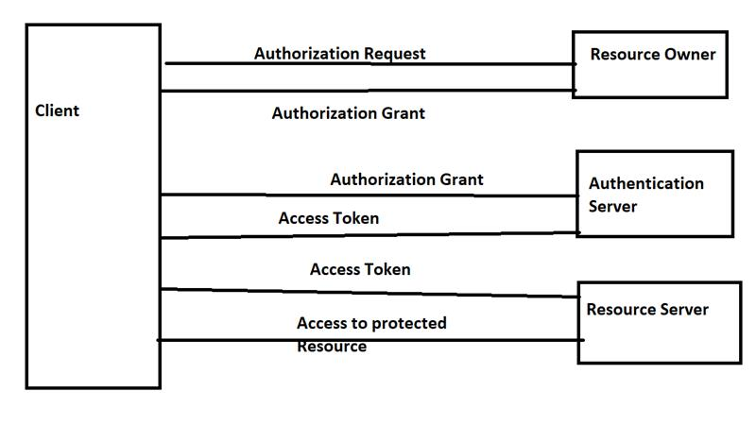

{​​​​​​

cleint id: "client",

grant_type: "password",

"username": "user1",

"password": "password1"

}​​​​​​

Terms used in OAuth2

Authorization Grant

## Steps to implement: